**Applecross Senior High School**



**Western Australian Certificate of Education**

**Semester One Examination, 2018**

**Question/Answer Booklet**

**MATHEMATICS**

____

98

**METHODS**

**UNIT 1**

**Section Two:**

**Calculator- assumed Score for this booklet**

**Student’s Name**: **_______________________________________**

**As shown on your exam timetable.**

**Student’s Teacher Mr Bradbury Mr Nesa**

(**Circle your teacher’s name**.)

**Ms Thamrin**

**Time allowed for this section**

Reading time before commencing work: ten minutes

Working time for this section: one hundred minutes

**Materials required/recommended for this section**

***To be provided by the supervisor***

This question /Answer Booklet

Formula Sheet (retained from Section One)

***To be provided by the candidate***

Standard Items: pens (blue/black preferred), pencils (including coloured), sharpener,

correction fluid/tape, eraser, ruler, highlighters.

Special items: drawing instruments, templates, notes on two unfolded sheets of A4 paper,

and up to three calculators approved for use in the WACE examinations.

**Important note to candidates**

No other items may be taken into the examination room. It is **your** responsibility to ensure

that you do not have any unauthorized notes or other items of a non-personal nature in the

examination room. If you have any unauthorized material with you, hand it to the supervisor

**before** reading any further.

|  |  |  |  |  |  |  |
| --- | --- | --- | --- | --- | --- | --- |
| Section | Number of questions available | Number of questions to be answered | | Working time (minutes) | Marks available | Percentage of exam |
| Section One:  Calculator-free | 8 | 8 | | 50 | 52 | 35 |
| Section Two:  Calculator-assumed | 13 | 13 | | 100 | 98 | 65 |
|  | | | **Total** | | 150 | 100 |

## Instructions to candidates

1. The rules for the conduct of examinations are detailed in the *School Examination Rules* provided with your exam timetable.Sitting this examination implies that you agree to abide by these rules.
2. Write your answers in this Question/Answer Booklet.
3. You must be careful to confine your responses to the specific questions asked and to follow any instructions that are specific to a particular question.
4. Spare pages are included at the end of this booklet. They can be used for planning your responses and/or as additional space if required to continue an answer.

* Planning: If you use the spare pages for planning, indicate this clearly at the top of the page.
* Continuing an answer: If you need to use the space to continue an answer, indicate in the original answer space where the answer is continued, i.e. give the page number. Fill in the number of the question(s) that you are continuing to answer at the top of the page.

1. **Show all your working clearly**. Your working should be in sufficient detail to allow your answers to be checked readily and for marks to be awarded for reasoning. Incorrect answers given without supporting reasoning cannot be allocated any marks. For any question or part question worth more than two marks, valid working or justification is required to receive full marks. If you repeat an answer to any question, ensure that you cancel the answer you do not wish to have marked.
2. It is recommended that you **do not use pencil**, except in diagrams.
3. The formula sheet and your notes are **not to be handed** in with your Question/Answer Booklet.

Section Two: Calculator-assumed 65% (98 Marks)

This section has**thirteen (****13)** questions. Answer **all** questions. Write your answers in the spaces provided.

Working time: 100 minutes.

Question 9 (4 marks)

The graphs of , and are shown below.

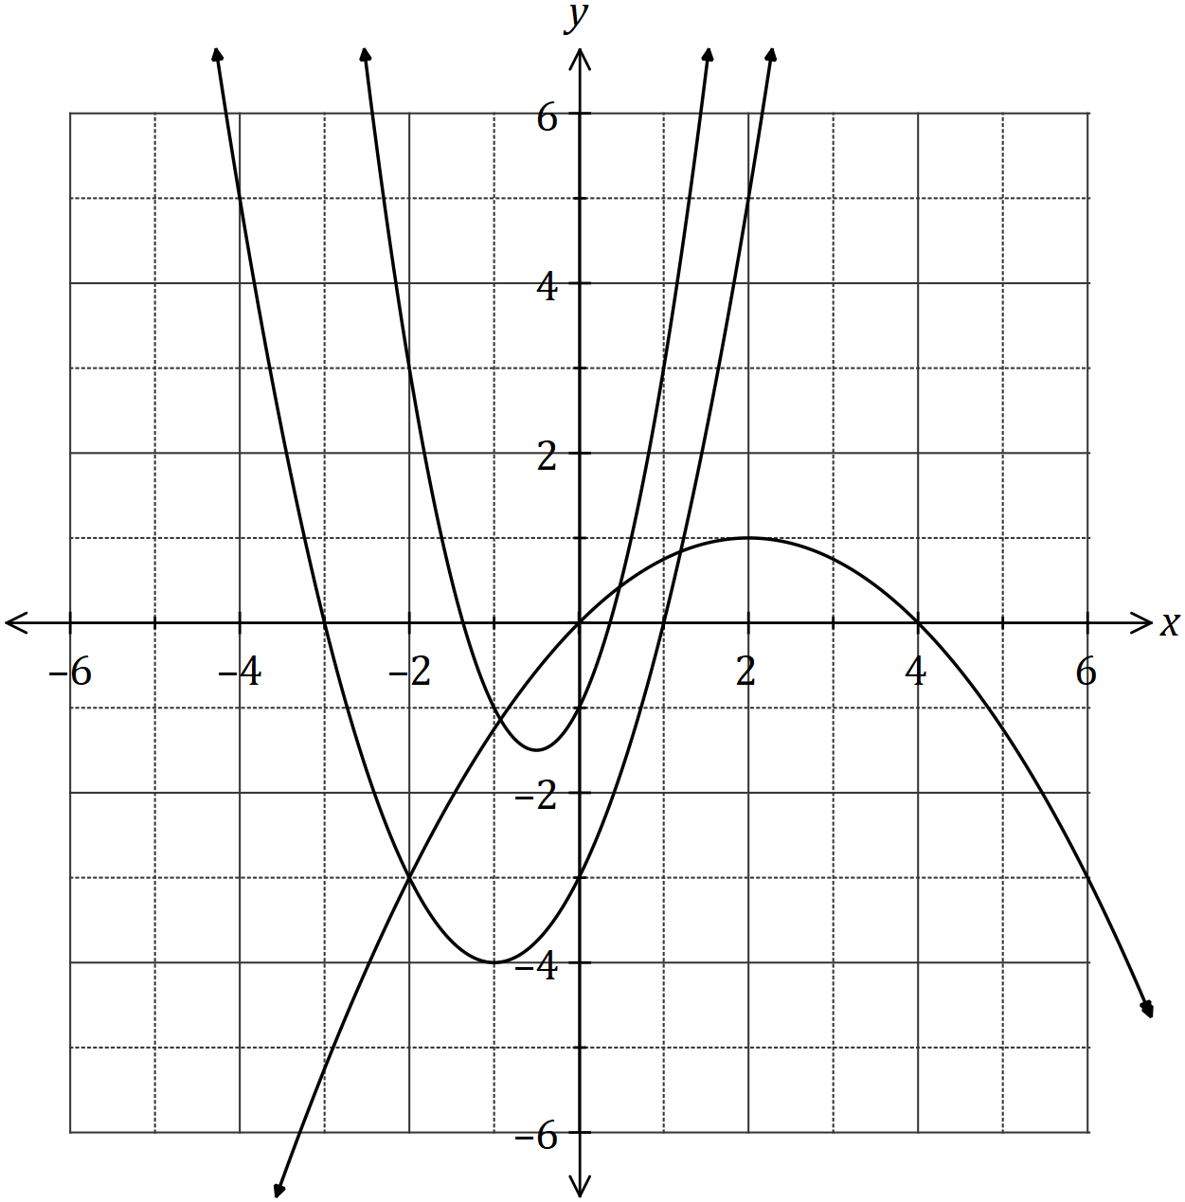

Determine the values of the constants and .

Question 10 (7 marks)

(a) The graph of a relationship is circular, as shown below.

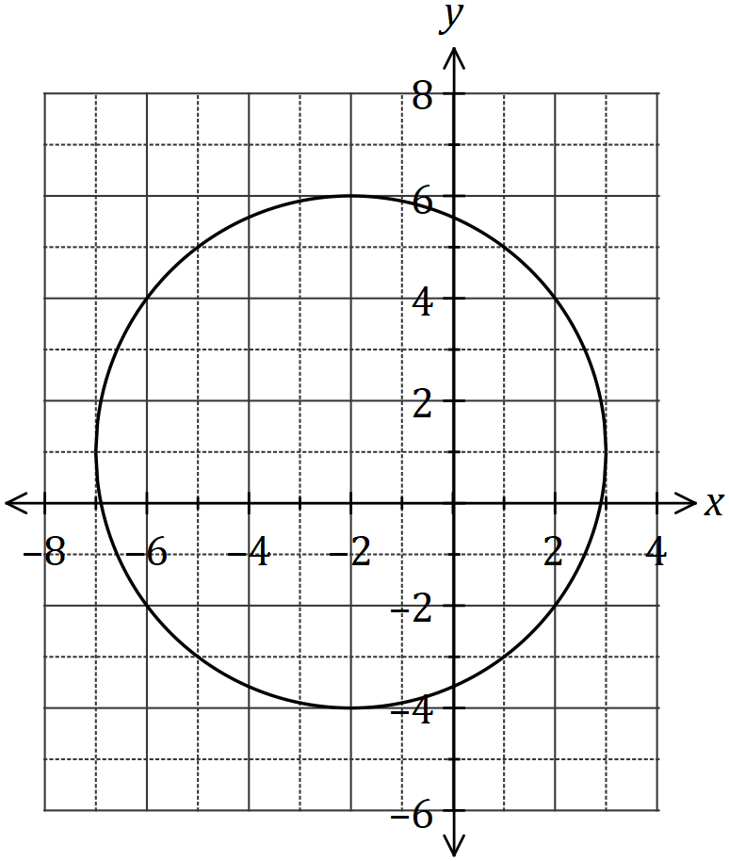

Determine the equation of this circle in the form ,

where and are constants. (4 marks)

(b) The line intersects the circle at the points and . Show that the line passes through the centre of the circle, and hence determine the distance . (3 marks)

Question 11 (6 marks)

A thin pole stands vertically in the middle of a level playing ground. From point on the ground, the angle of elevation to the top of the pole, , is 18º.

From point , also on the ground but 5.35 metres further from the foot of the pole than , the angle of elevation to the top of the pole is 15º.

(a) Draw a sketch to represent this information. (1 mark)

(b) Showing use of trigonometry, determine the height of the pole. (5 marks)

Question 12 (7 marks)

Let and , where and are constants.

The graph of is shown below.

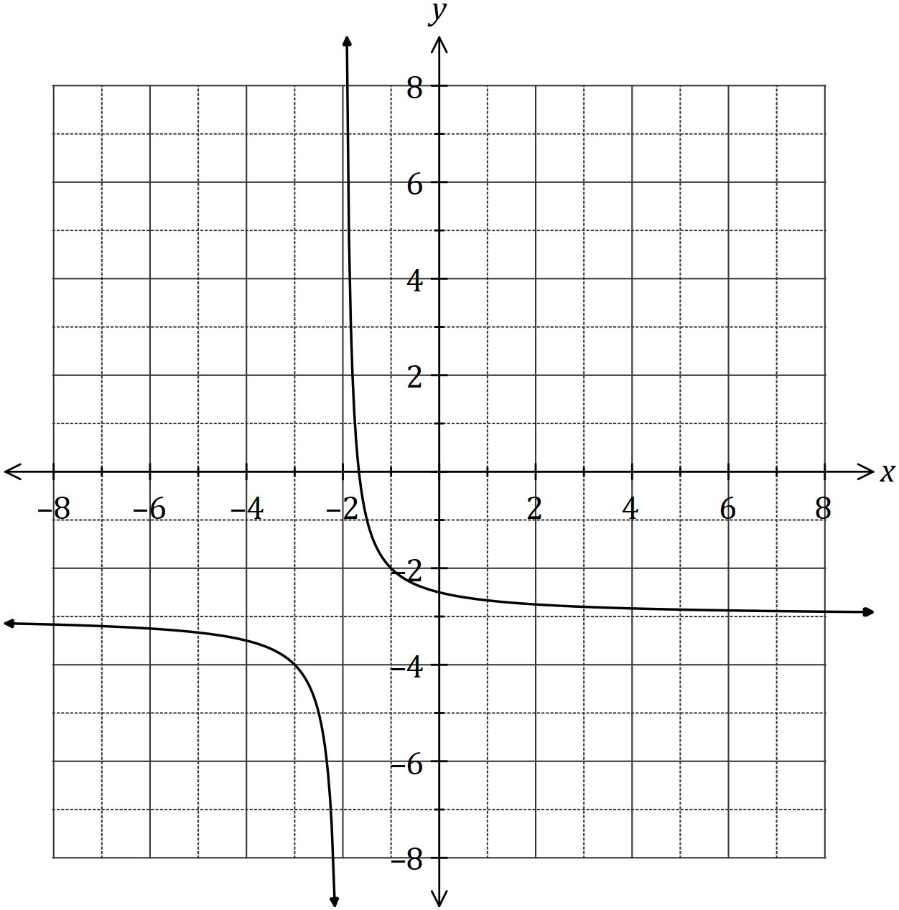

(a) Sketch the graph of on the axes above. (3 marks)

(b) Determine the values of and . (2 marks)

(c) Solve the equation , giving your solution(s) to one decimal place. (2 marks)

Question 13 (6 marks)

(a) Determine the equation of the axis of symmetry for the graph of .

(2 marks)

(b) The graph of passes through the points and . Determine the values of the constants and . (4 marks)

Question 14 (10 marks)

A logo with triangular outline contains a shaded segment bounded by the straight line and the circular arc with centre and radius cm, as shown below.

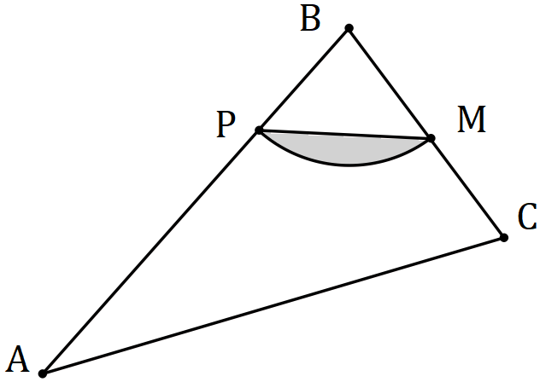

Given that , and is the midpoint of , determine

(a) the size of in degrees. (1 mark)

(b) the area of the shaded segment. (2 marks)

(c) the perimeter of the shaded segment. (3 marks)

(d) the area of triangle . (4 marks)

Question 15 (9 marks)

(a) The graphs of the following, where and are constants, are shown below.

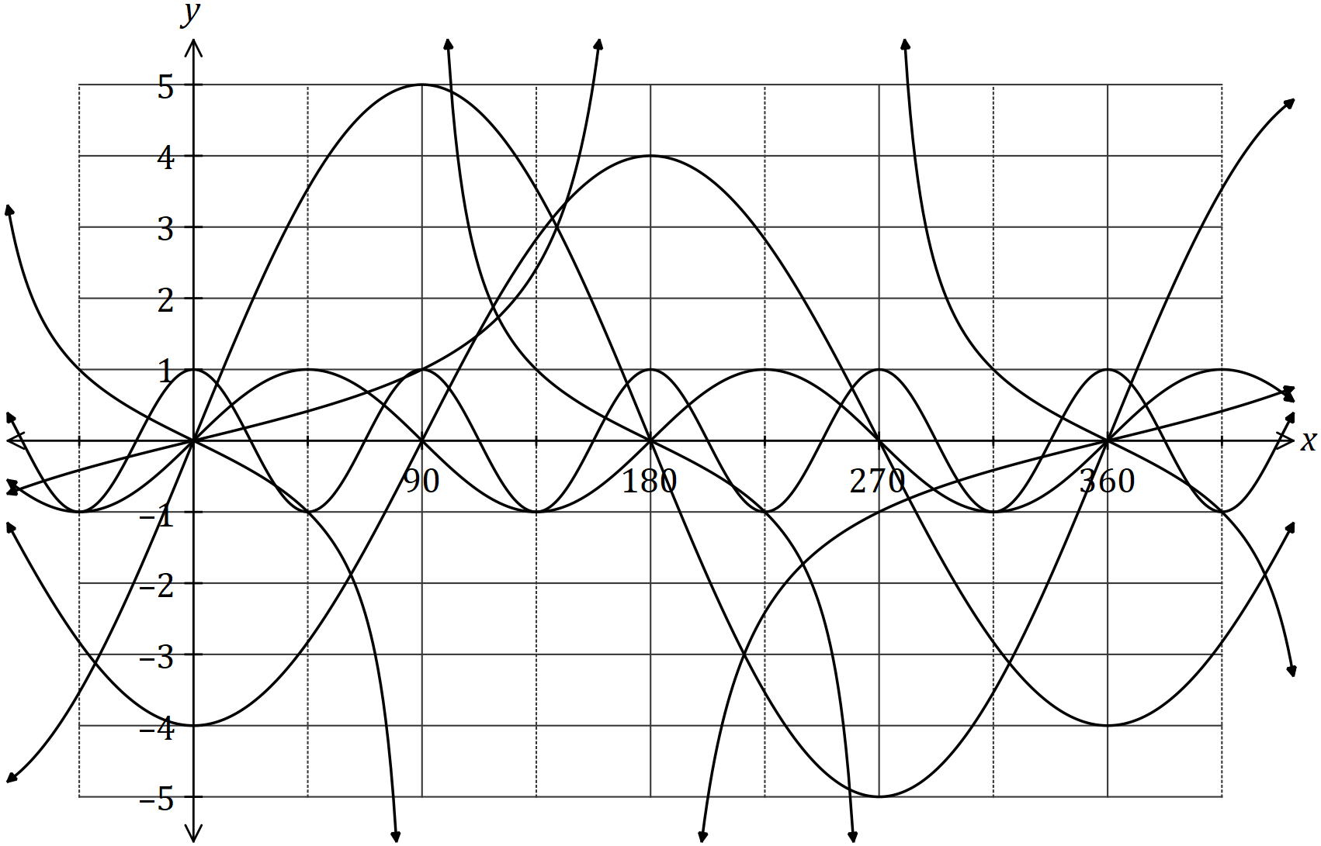

State the values of and . (6 marks)

|  |  |
| --- | --- |
| Constant | Value |
|  |  |
|  |  |
|  |  |
|  |  |
|  |  |
|  |  |

(b) Calculate the acute angle in degrees between the lines and ,

rounding your answer to one decimal place. (3 marks)

Question 16 (6 marks)

(a) The graph of is shown in bold below. The graphs of and are also shown, where and are constants.

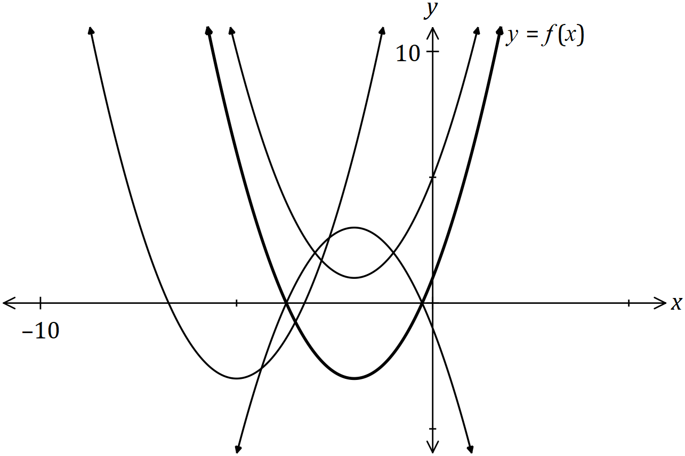

Clearly label the remaining graphs with or .

(3 marks)

(b) The one-to-one relation has domain and range given by and respectively. Determine the values of constants and . (3 marks)

Question 17 (9 marks)

The wind speed at a weather station, metres per second, hours after recording began, can be modelled by the function

(a) Calculate the wind speed when . (1 mark)

(b) Sketch the graph of wind speed against time on the axes below. (4 marks)

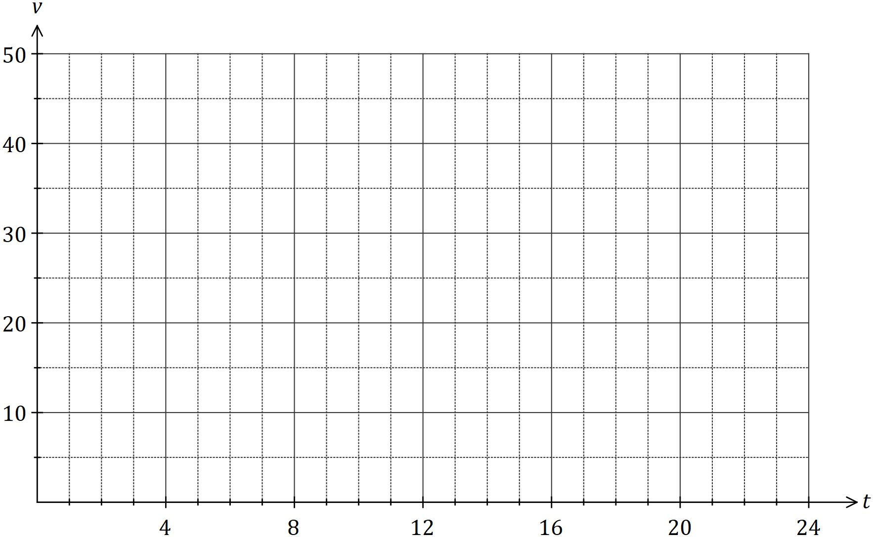

(c) During the 24-hour period, determine

(i) the time at which the wind speed was greatest. (1 mark)

(ii) the minimum wind speed. (1 mark)

(iii) the length of time, in hours and minutes, that the wind speed was increasing.

(2 marks)

Question 18 (6 marks)

(a) Part of the graph of is shown below, where , and and are constants.

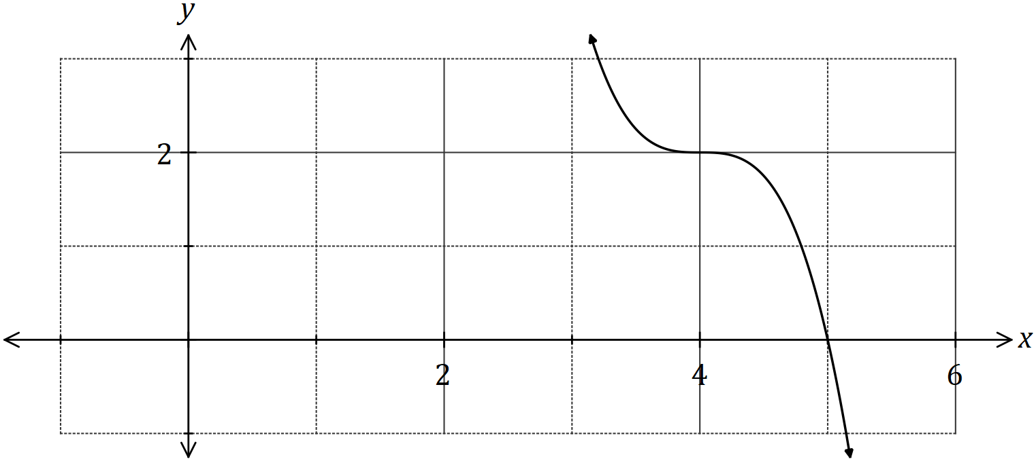

(i) State the degree of . (1 mark)

(ii) Determine the value of . (1 mark)

(iii) Determine . (2 marks)

(b) Another function is given by .

Describe how to obtain the graph of from the graph of . (2 marks)

**Question 19 (13 marks)**

(a) The cross-section of a wooden hand rail is formed by the intersection of two quadratic functions shown below. The upper curve is modelled by the equation 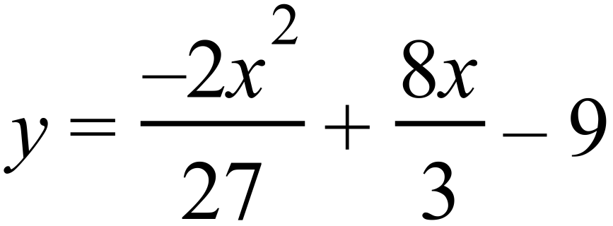 .

The equation of the lower curve is a quadratic of the form 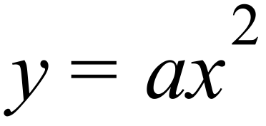 .

The two curves meet at 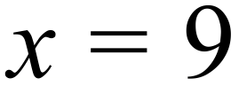 .

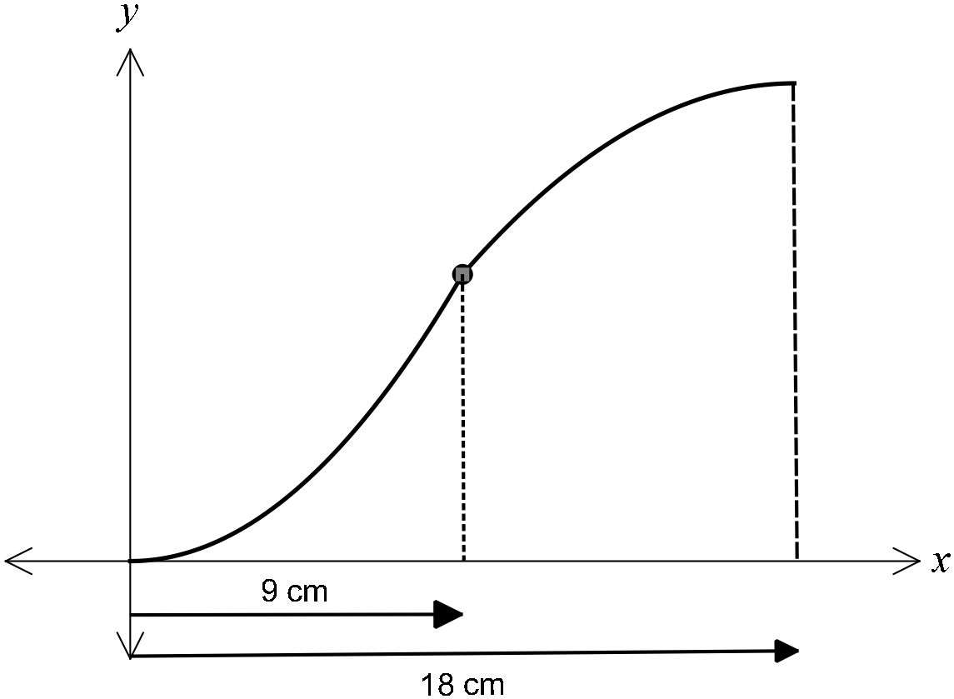

(i) Determine the coordinates of the point where the two curves meet. (1 marks)

(ii) Determine  and hence state the equation of the lower curve (2 marks)

(iii) If the hand rail was moved up 3 cm, determine the new equations of the upper

and lower curves. (1 marks)

(b) Determine the equation

(i) of the line passing through the point 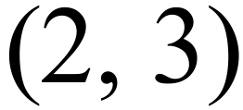 and parallel to the line with

equation 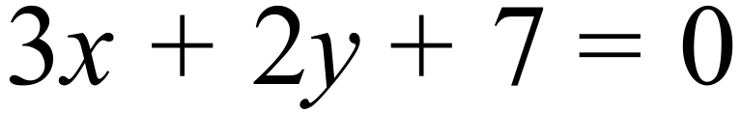 (2 marks)

(ii) of the line which is the reflection of the line 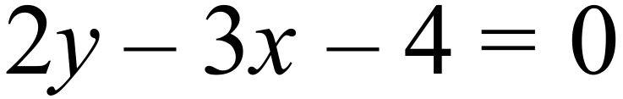 in the y-axis (2 marks)

(c) Consider a rope fixed at B and tightly wrapped around a disc A as shown in the diagram below.

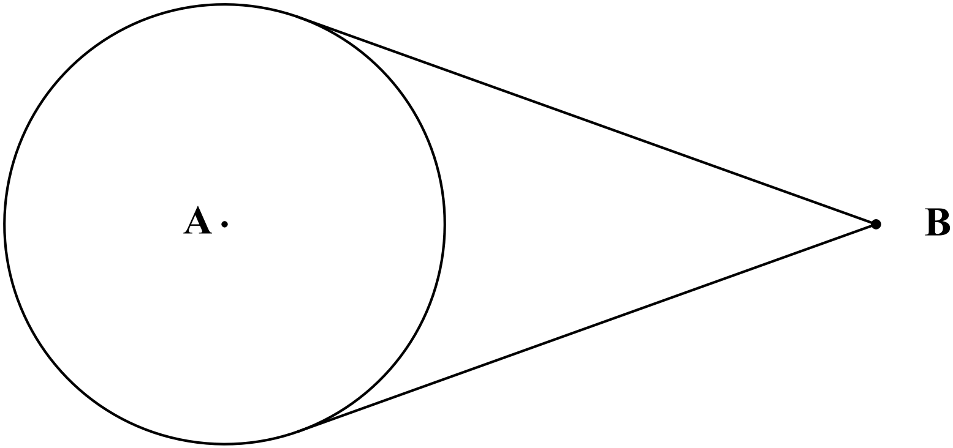

Given that disc A has a radius of 10 cm and the distance of B from the nearest edge of

disc A is twice the radius of disc A, determine the length of the rope. (5 marks)

Question 20 (7 marks)

Consider the points with coordinates and that lie in the first and second quadrants respectively of the unit circles shown below, where and are acute angles.

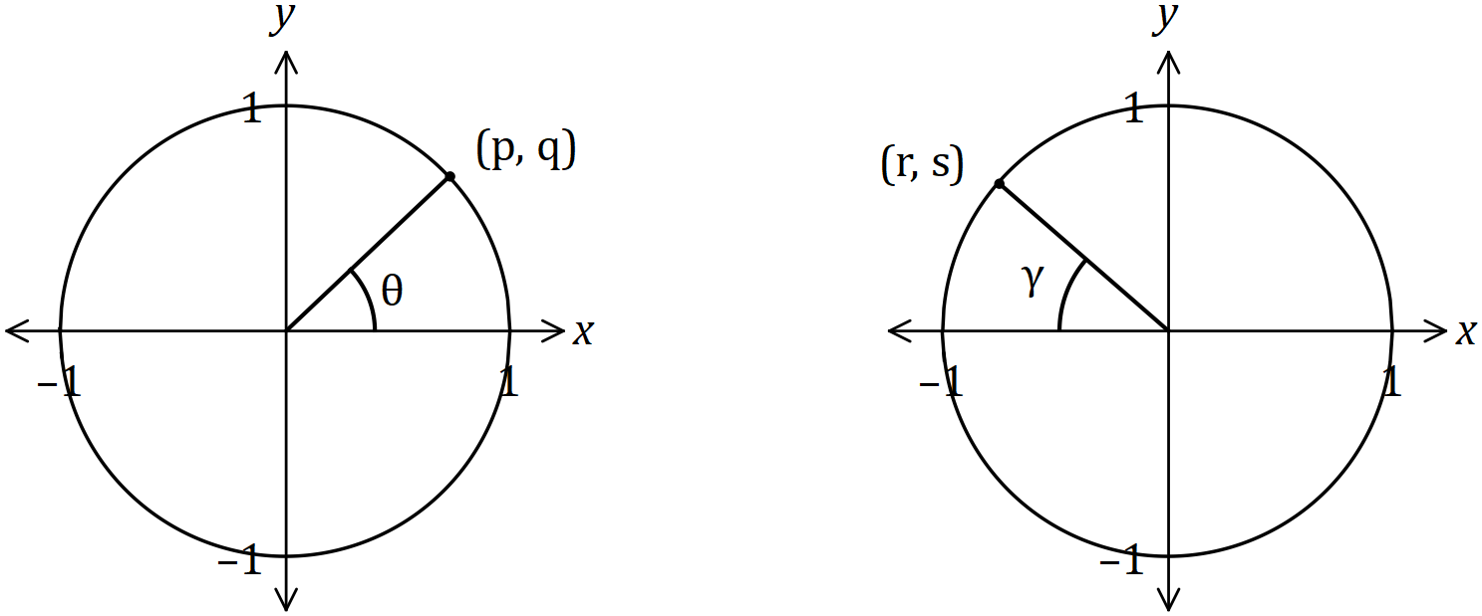

Determine the following in terms of and , simplifying your answers where possible.

(a) . (1 mark)

(b) . (1 mark)

(c) . (2 marks)

(d) . (1 mark)

(e) . (2 marks)

Question 21 (8 marks)

(a) For a given set of numbers the set of points  is defined as follows:



1. State the Domain of  (1 mark)
2. State the Range of . (2 marks)

(b) If the set is redefined as follows:



1. List the elements of  (2 mark)
2. State the Range of. (1 marks)

(c) Comment on whether either of  would qualify to be called a function?

Justify your comment. (2 marks)

**Additional working space.**

**Question Number:_________**

**Additional working space.**

**Question Number: _________**

**Additional working space.**

**Question Number: _________**